Practical No:06
Aim: Design an empliment an expration using multiplexer in logism.

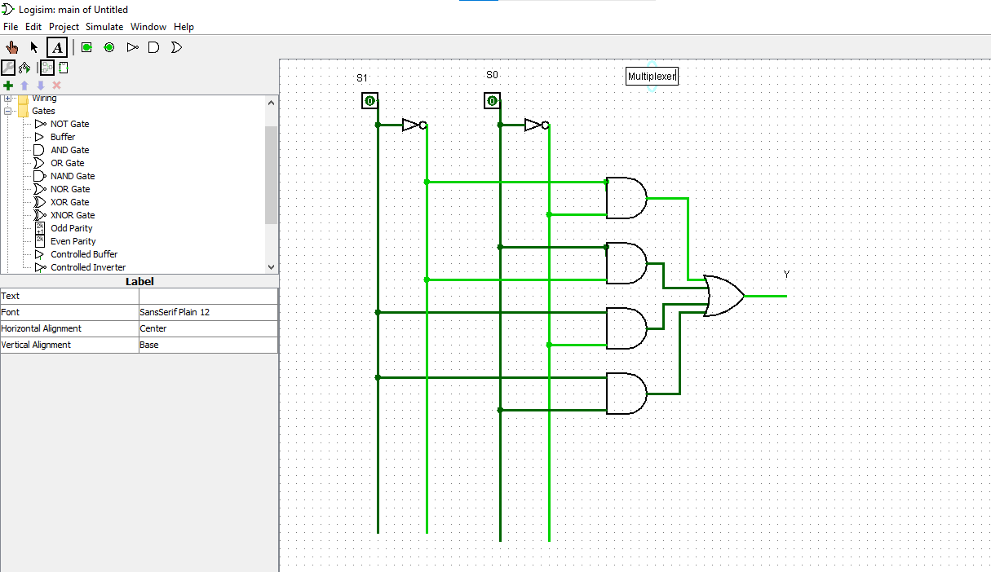

Name: Roshan dhaigude
Sub: Digital System & Architecture
Class:FYBs CS
Roll no:
Sign:

